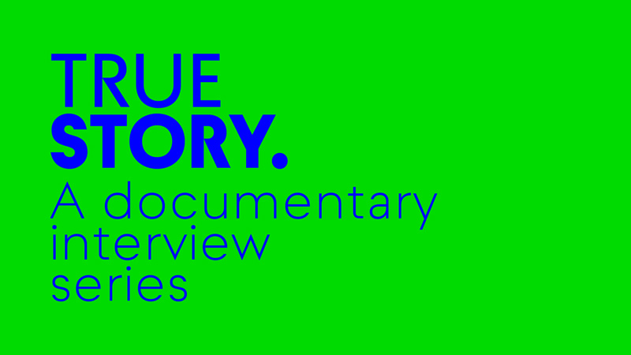
Press Release, Prague, November 9, 2020

Announcing True Story.
A Documentary Interview Series
Institute of Documentary Film and Film New Europe are happy to announce the new collaboration project, the podcast series dedicated to the documentary film of Central and Eastern Europe: True Story.
True Story: a documentary video and podcast interview series; almost everything you ever wanted to know about Eastern European documentary film.
In-depth interviews, analysis, field reports, live events and much much more with your curious and enthusiastic hosts, Ivona Remundova and Nicole Jennifer Adelman.
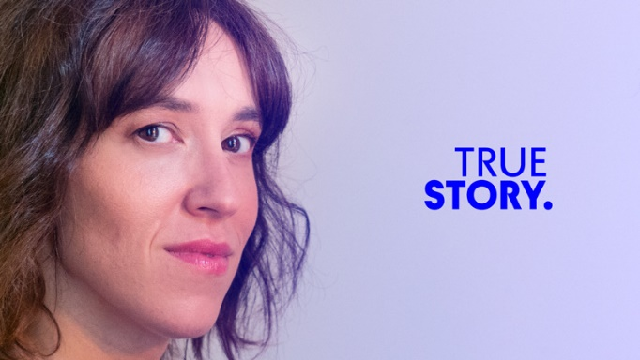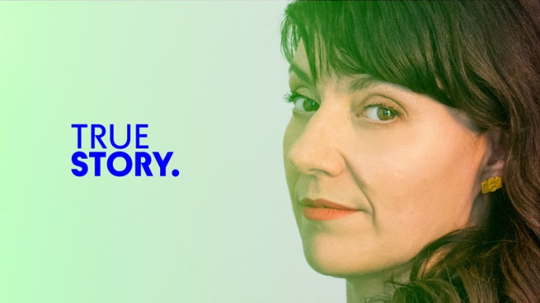
Ivona Remundova Nicole Jennifer Adelman

The series of 10 episodes will interview filmmakers on their recently finished documentaries. We would love to introduce you to a documentary landscape of Central and Eastern Europe, present you new talents and raising stars, but also discuss with the documentary masters. In the end, it all will lead you to a discovery of new films that should not be missed.
The first podcast from the True Story series brings an interview with producer/co-writer Liis Nimik and director Carlos E. Lesmes López about their new documentary A Loss of Something Ever Felt, a gripping story about a young Estonian drug addict who goes missing, and his sister who searches for him in the dangerous corners of Bogotá, where no one seems to go.
This series is brought to you by the Institute of Documentary Film in Prague and Film New Europe.
For now twenty years, the Institute of Documentary Film (IDF) has been helping documentary filmmakers and their audiences to discover and uncover a wide range of topics, from important social issues to intimate stories of interesting people. Documentary is no longer perceived as merely descriptions of reality in distant cultures or animal life. Documentary film has become a key catalyst of critical social change, reflecting human challenges and identifying laws or cultural rules that no longer apply, while deepening the artistic practice of filmmaking.
The Film New Europe Association is the main networking platform of professionals in the Central and Eastern Europe and Baltic region as well as Cyprus and Malta. It’s main goals are sharing of know how, visibility of regional cultural diversity and finally the voice of the region and connecting partnerships and activities with the main pan-European film institutions based in Western Europe. Its flagship publication is FNE Daily with news about 18 countries delivered to a global audience of film professionals every day. Join the network of Europe’s most successful film professionals at www.filmneweurope.com
We simply enjoy a good talk about the films we like and hope you will too!
Institute of Documentary Film & Film New Europe
Listen to the True Story podcast series
- on Soundcloud: https://soundcloud.com/idf-true-story
- on Podbean: https://idf.podbean.com/
- on Anchor: https://anchor.fm/idf-true-story
- on Spotify: https://bit.ly/idf-true-story

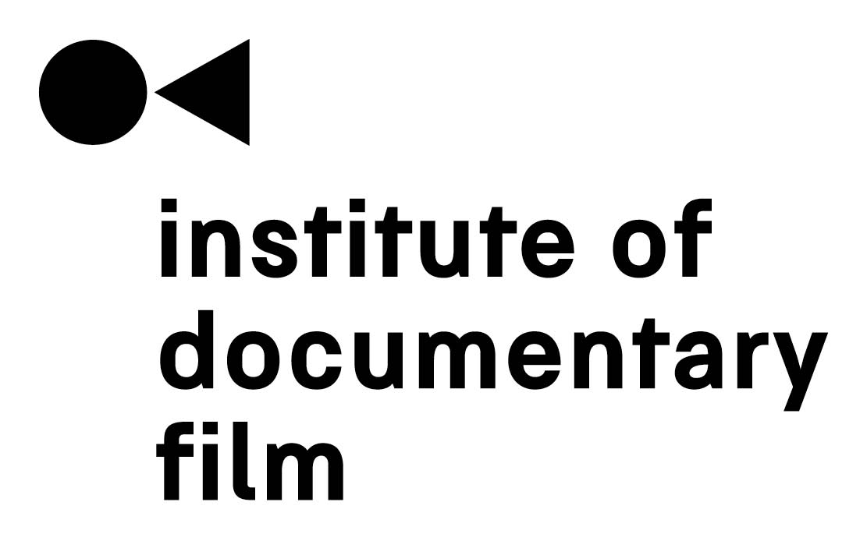

Contact
Veronika Zýková
IDF Project PR Coordinator
zykova@dokweb.net
+420 736 116 013

