PRESS RELEASE, Prague, August 18, 2020
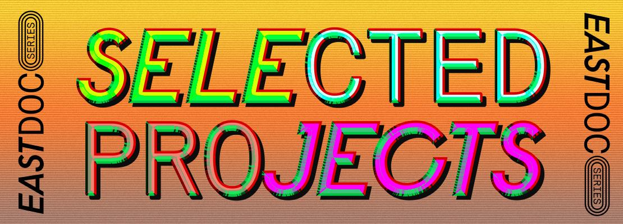
East Doc Series reveals five selected projects
Five projects have been selected for the first session of East Doc Series, which will take place online at Baltic Sea Docs on September 2 & 7 – 8, 2020. The selection includes documentary series by Hungarian director Bernadett Tuza-Ritter (A Woman Captured, 2017) and Bulgarian duo Boris Missirkov and Georgi Bogdanov (Palace for the People, 2018).

East Doc Series, a brand new programme organized by the Institute of Documentary Film in association with Baltic Sea Docs and Sunny Side of the Doc, has revealed the projects selected for the first session. Five director-producer teams will take part in the first session at Baltic Sea Docs online market on September 2 and 7 – 8, 2020.
Among the selected docu-series is Nikolai Galitzine’s Prophet of Doom, an investigation into the unsolved mystery of a brilliant Soviet climatologist who vanished in Madrid at the height of the Cold War. Queen of Chess by Bernadett Tuza-Ritter tells the story of the relationship and the games of two minds: Judit Polgar, the greatest female chess player of all time, and Garry Kasparov, the legend who believed that a woman and a man cannot fight. Tin Can Race by Boris Missirkov and Georgi Bogdanov explores the pleasures that old socialist cars can still provide: “Speed, freedom, love, hate, industrial espionage - let’s drive again the most popular Socialist cars that made it to the fall of the Berlin Wall that some of them even survived!”

Saša Ban’s third season of Slumbering Concrete will also take part in the East Doc Series programme. It focuses on some of the greatest examples of 1960’s and 1970’s modernist architecture in former Yugoslavia, and its influence on people’s life then and now. Margit Lillak’s docu-series Villages of Light tells the stories of 6 most outstanding intentional eco-communities of Europe. The series explores how the way of co-living expands the consciousness, finds new models for sustainable living and spiritual awakening.

Sergei Trofimov, the Coordinator of East Doc Series programme, explains the criterias on which the selection of 5 projects was made: “One of the most crucial elements which was taken in consideration from the beginning was the accordance of the project to classical or traditional television slots. As a result, 5 projects selected for the programme match to Architecture, History, Sport, Science, Crime, Investigation and Society slots. That means a clear representation for potential co-producers, decision makers and broadcasters.”

The introductory session of East Doc Series includes pre-scheduled individual meetings with decision makers – producers, broadcasters from European television, representatives of funds, digital platforms and VoD. The programme offers consultations, lectures and case studies on various aspects of docu-series.

Among the experts and tutors of the first session of East Doc Series is Fernanda Rossi, an internationally renowned speaker, writer and film theorist, who has collaborated on over 500 documentaries and screenplays, including two nominated for the Academy Award® and one nominated for Best Screenplay for the Panda Awards®. Her book Trailer Mechanics: How to Make your Documentary Fundraising Demo, 2nd Edition, is according to industry professionals the bible on demos.

Amanda Feldon will be joining the East Doc Series programme as well. She is an Executive Producer, Director and Scriptwriter with more than 35 years of experience making award-winning documentaries and programmes all over the world for international broadcasters including the BBC, CNN, Discovery Channel, Animal Planet National Geographic, Netflix, and many others. She currently works as a Senior Production Consultant to the Creative Content Fund in Brussels and Kyiv.
The second session will take place in Prague, March 6 – 12, 2021, at East Doc Platform. The open call will run from September 1 until November 13. The third session will be held within Sunny Side of the Doc in La Rochelle from June 21 – 24, 2021.
SELECTED PROJECTS:

Prophet of Doom
Directed by Nikolai Galitzine
Produced by Łukasz Długołęcki (NUR), Haukur Hrafnsson (NUR) and Andrew Revkin
Co-produced by Artem Vasiliev (METRAFILMS) and Asya Pavlovskaya (METRAFILMS)
Poland, Russia, Spain, Ireland

On 31st March 1985, Vladimir Aleksandrov, a Soviet climatologist, vanished whilst on a trip to Spain. He had just come from attending an international peace mission to the Vatican. He had been imploring the world not to use their nuclear weapons, as a limited exchange could cause what he and his fellow climatologists called a Nuclear Winter. This would spell total extinction. But Vladimir's open, honest and exuberant nature led him towards great danger.

Slumbering Concrete (season 3)
orig. Betonski spavači
Directed by Saša Ban
Produced by Dana Budisavljević (HULAHOP)
Croatia, Slovenia, Serbia

The series critically explores the fate of buildings that have lost their original purpose to protect the political system but have not lost their cultural and spatial significance. Can we stop our recent history to be completely wiped-out and take a critical look at the achievements of one whole generation? Can we remove the stigma of the ideological enemy from some of the greatest examples of our architectural legacy? And ultimately, by doing so, can we establish some continuity in our urban and cultural history?

Queen of Chess
Directed by Bernadett Tuza-Ritter
Produced by László Józsa (Speak Easy Project) and Peter Stern
Co-produced by Heino Deckert (Deckert Distribution GmbH)
Hungary, Germany

Laszlo and Klara Polgar, the Hungarian teachers decided to raise geniuses in socialist Hungary as an experiment. When Judit, the youngest, challenges her all-time favorite master, Kasparov, the 16-year-old girl gains a draw. For the best player in the world, it is not an easy take from a girl. They keep on fighting until he invites her to his chess camp in Greece. In 2002, Judit Polgar defeated Garry Kasparov.

Tin Can Race
Directed by Boris Missirkov and Georgi Bogdanov
Produced by Martichka Bozhilova (AGITPROP)
Bulgaria

During the Cold War, the average family in the Eastern-bloc sooner or later had its long-awaited, much loved, polished and groomed socialist clumsy and a pain-to-drive car. And this was the only available option. On the other hand, the export of these cars was a national priority of the communist countries, so that many families in the West “enjoyed” a pure utilitarian and very affordable model of a Lada, Moskvich, Skoda or Yugo. The socialist cars were meant to serve their owners and not to bring pleasure. Now it’s time to revive these old monsters and have all the joy they can provide.

Villages of Light
Directedy by Margit Lillak
Produced by Volia Chajkouskaya (Allfilm)
Estonia
Two hosts – an open minded couple Liina (Estonia) and Pierre (France), take a road trip to the European communities, to explore the possibilities of polyamory and sustainable living, and to experience life in different communities by taking part in the daily life, practices and rituals: liberating the Eros in a collective forum and transforming society into a more peaceful world (Tamera/Portugal), participating in Theurgic magical secret rituals, that change the vibration of Gaia, building interdimensional gates with guardians (Damanhur/Italy) and more.

1st session: “Episode 1: The Pilot” – Baltic Sea Docs, Riga, Latvia (September 2 & 7 – 8, 2020, online session)
2nd session: “Episode 2: The Pitch” – East Doc Platform, Prague, Czech Republic (March 6 – 12, 2021)
3rd session: “Episode 3: The Market” – Sunny Side of the Doc, La Rochelle, France (June 21 – 24, 2021)
Contact:
Veronika Zýková / Project PR Coordinator / +420 736 116 013 / zykova@dokweb.net

