Museum of the Revolution wins East Doc Platform Award

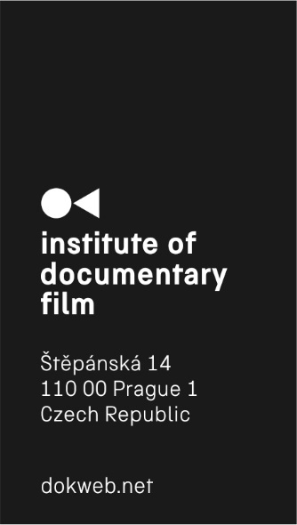
For the 8th year, the biggest platform for Central and East European documentaries took place in Prague on March 9–15. Approximately 350 film professionals came to the East Doc Platform from all over the world. Around 50 documentary projects in various stages of development and production competed to be awarded with several prizes worth €17 800 in total. The main prize, the East Doc Platform Award, worth €7500, was given by an international jury to the Serbian/Croatian film Museum of the Revolution, in which the director Srđan Keča explores the untraditional friendship across generations of women in the ruins of an unfinished monumental museum. Myrocia Watamaniuk (Hot Docs) read the statement of the jury: “We were all, each of us, absolutely struck by the visual artistry that transports viewers to literally another world that is not long for this one, the one that is disappearing. We are unanimous in our decision that Museum of the Revolution should receive this award.” An Honorable Mention went to the Czech project by Martin Páv, Wolves on the Borders! The jury felt the creators “did an incredible job of showing us how people need to make room for non-humans in our world and how fear can motivate people to do incredibly ridiculous things, fear of the imaginary and the real.”

The HBO Europe Development Award worth €2000 was awarded to the Russian filmmaker Anna Shishova-Bogolubova for her The New Imperium. The Czech Television Co-production Award goes to A Marriage, a Czech/US co-production by Kateřina Hager and Asad Faruqi. Representatives of Current Time TV channel have decided to support Russian/Estonian Susanna Baranzhieva’s and Aleksander Krylov’s Untitled Rastorguev Project with €1500. The Golden Funnel Award was given to the project which made the greatest progress throughout the Ex Oriente Film workshop; Czech-Japanese director Haruna Honcoop was awarded for her ambitious co-production Olympic Halftime in which she explores the effects of Olympic games in Japan, China and France.
At the East Doc Platform, festival representatives selected the best projects, giving their creators greater access to present them at prestigious events. The winner of the East Doc Platform Award, Museum of the Revolution, got the IDFA Forum Award. The upcoming Ukrainian film by Ihor Ivanko, Fragile Memory, got the DocsBarcelona Award. Two awards were given by the representatives of DOK Leipzig – one to the Russian director Nikolay Bem for The Pit and the second to the Serbian project Bottlemen by Nemanja Vojinović. The Czech documentary set in Sweden, Kiruna – A Brand New World, by Greta Stocklassa got the Sheffield Doc/Fest Award for the best project at Czech Docs… Coming Soon presentation. The new Sunny Side of the Doc Award was given to the creators of the Olympic Halftime.

