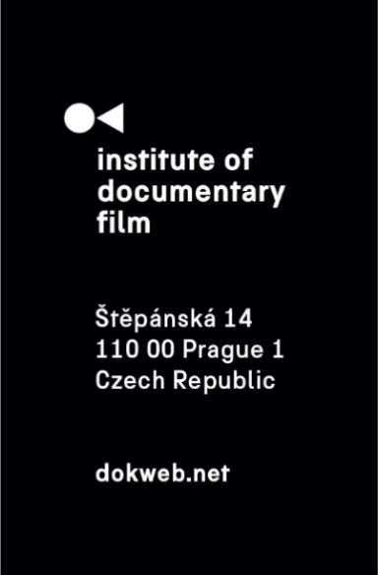
Press Release, Prague, October 31, 2020

Silver Eye Award 2020 for Jindřich Andrš’s A New Shift

Silver Eye Award 2020 for the best feature length film in the East Silver Market, given by the Institute of Documentary Film at Ji.hlava IDFF, goes to Jindřich Andrš for his A New Shift. Mohammed Almughanni got the award in short length category for his film Son of the Streets. Special Mention goes to Hanna Hovitie's To Feather, to Wither.
The Silver Eye Award for the best feature length film in the East Silver Market, given by the Institute of Documentary Film since 2009, received Jindřich Andrš for his film A New Shift. The Jury comprised of Tomáš Poštulka (One World IHRDFF Programmer), Michaela Čajková (Sales Agent, Filmotor) and Ondřej Kazík (Head of the Program, AFO) stated:
“We have decided to give the Silver Eye Award 2020 to the film that picked our interest because of its very current and burning issue it depicts. We were also charmed by the sensitive approach to the protagonist and the place it captures. The director spent several years of his life with the story he devoted his short and feature film to. Nevertheless, he kept his perspective and humble approach. In our opinion, this documentary perfectly represents the region of Central and Eastern Europe and has a potential to resonate in the wider international context. The winner of this year’s Silver Eye Award is A New Shift by Jindřich Andrš.”
A New Shift, which was developed within our Ex Oriente Film workshop, has also won the Czech Joy competition, where another Ex Oriente Film 2018 project received the Special Mention. Last but not least, Latvian Coyote by Ivars Zviedris (Ex Oriente Film 2016) has won the Between the Seas competition.
Silver Eye Award for the best short documentary in the East Silver Market goes to Mohammed Almughanni for his film Son of the Streets. The Jury, comprised of Christine Camdessus (FIPADOC Festival Director), Veronika Janatková (DokuBaku Co-founder & Programmer) and Diana Tabakov (Doc Alliance Film Executive Director), pointed out in the statement: "How unwelcome can one be in this world? A very unique connection with characters allows the director to unfold the nature of Khodor's vital dilemna in a vivid and profoundly memorable way. The vigorous cinematic experience engraves in the viewer the complex reality of daily life in a camp."
The Jury has decided to give Special Mention to Hanna Hovitie's film To Feather, to Wither: “For outstanding directing skills that have given life to the deceased. The director has created a tender portrait of the poetics of the cycle of life.”
This year, 11 films were nominated in the feature length category and 8 in the short category. The winners of both categories receive 2500 € and a support from the East Silver Caravan for one year in form of the help with festival distribution.

Silver Eye Award 2020 nominees – feature length documentaries:
A Loss of Something Ever Felt (Carlos Eduardo Lesmes López, Estonia, 2020)
Salt from Bonneville (Simon Mozgovyi, Ukraine, Poland, Georgia, 2020)
A New Shift (Jindřich Andrš, Czech Republic, 2020)
Her Mothers (Asia Dér, Sári Haragonics, Hungary, 2020)
Wolves at the Borders (Martin Páv, Czech Republic, 2020)
Inner Wars (Masha Kondakova, Ukraine, France, 2020)
Town of Glory (Dmitry Bogolyubov, Russia, Czech Republic, Germany, 2020)
Say Yes / No (Pawel Hejbudzki, Poland, 2020)
The Jump (Giedrė Žickytė, Lithuania, Latvia, France, 2020)
Running on Empty (Lisa Weber, Austria, 2020)
Merry Christmas, Yiwu (Mladen Kovačević, Sweden, Serbia, France, Germany, Belgium, Qatar, 2020)
Silver Eye Award 2020 nominees – short documentaries:
The First Bridge (Laila Pakalnina, Latvia, 2020)
All Our Nights (Nicolle Reale, Viv Li, Zsófia Paczolay. Hungary, 2020)
Hitting my Head on the World (Anna Vasof, Austria, 2019)
Son of the Streets (Mohammed Almughanni, Poland, Lebanon, 2020)
Outsiders (Almantas Petkunas, Lithuania, 2019)
We Have One Heart (Katarzyna Warzecha, Poland, 2020)
To Feather, to Wither (Hanna Hovitie, Hungary, 2020)
I am Wounded (Orkan Bayram, Germany, Latvia, 2020)

Contact:
Veronika Zýková
IDF Project PR Coordinator
zykova@dokweb.net
+420 736 116 013

