PRESS RELEASE, Prague, July 22, 2020
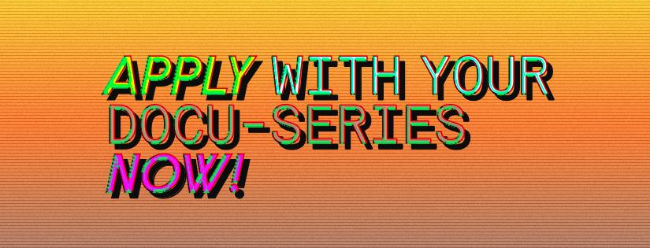
East Doc Series – a brand new programme for documentary series
The Institute of Documentary Film launches the East Doc Series – a brand new programme for documentary series focused on consultations and networking, connecting three European film markets. The first session will take place online as part of Baltic Sea Docs (September 2 & 7 – 8, 2020), the second part will be held within East Doc Platform in Prague (March 6 – 12, 2021), while the final session will take place at Sunny Side of the Doc in La Rochelle (June 21 – 24, 2021). The call for the first session is open until August 10, 2020.
East Doc Series is a new activity responding to the emerging trend and new genre in high demand: the documentary series. The activity is designed to provide necessary feedback and know-how from film professionals and creators to filmmakers in Central and Eastern Europe, where the formats of docu-series is growing in popularity among audiences.
“We are looking for new docu-series projects coming from the region in order to help them to reach international markets. The programme is structured in the form of three connected events hosted at three different European film markets over the period of 2020/2021,” says Zdeněk Blaha, the Programme Director of the Institute of Documentary Film. The East Doc Series programme aims on creating opportunities for documentary series, offering feedback and consultations with experienced producers and broadcasters, help with development of docu-series, finding the story arch, offering ideas on various platform differences and formats (creating series for TV and digital platform), as well as to provide space for networking.
The programme connects three European documentary markets and addresses different issues of documentary series production:
- 1st session: “Episode 1: The Pilot” – Baltic Sea Docs, Riga, Latvia (September 2 & 7 – 8, 2020, online session)
- 2nd session: “Episode 2: The Pitch” – East Doc Platform, Prague, Czech Republic (March 6 – 12, 2021)
- 3rd session: “Episode 3: The Market” – Sunny Side of the Doc, La Rochelle, France (June 21 – 24, 2021)

1st session: “Episode 1: The Pilot” – Baltic Sea Docs, Riga, Latvia (September 2 & 7 – 8, 2020)
The first session will consist of three days of consultations at Baltic Sea Docs in Riga, Latvia, co-production market and pitching forum for Baltic Sea Region and surrounding countries. The first session will be held online within the programme of Baltic Sea Docs.
For the first session, up to 5 projects will be selected from open call for entries for projects from Central and Eastern Europe. The introductory session will provide consultations and feedback from international experts, producers of successful docu-series etc.
2nd session: “Episode 2: The Pitch” – East Doc Platform, Prague, Czech Republic (March 6 – 12, 2021)
The 2nd session, which takes place at the East Doc Platform (EDP), will focus on enhancing international and competitive potential, offer wide networking options, including pitch and individual one-on-one meetings, as well as building visibility for the selected projects. Projects will be part of the East Doc Forum, the public pitch presentation and East Doc Market, pre-scheduled individual meetings. Producers will go through a preparatory phase which will help them prepare their pitch. The overall programme is focused on networking and market meetings with decision makers.
3rd session: “Episode 3: The Market” – Sunny Side of the Doc, La Rochelle, France (June 21 – 24, 2021)
Sunny Side of the Doc represents an important international market for meeting broadcasters, sales agents and other key decision makers not only from France. The focus and position of this market makes it a logical step for the last session of the East Doc Series programme, since it offers the possibility to meet many potential partners not only for the docu-series projects, but for establishing connections for other projects too, including feature-length and TV documentaries, as well as VR/AR and cross-media. In cooperation with Sunny Side of the Doc the third session will welcome a delegation of East European professionals who will attend with their projects and gain exclusive access to decision makers and individual meetings.
About the Institute of Documentary Film
Institute of Documentary Film (IDF) has been supporting creative documentary films from Central and Eastern Europe since 2001. IDF provides both emerging and experienced filmmakers with training, financing, networking and pitching opportunities, helps them get international attention and co-productions, rewards the exceptional projects with awards and further opportunities and improves their orientation on the international market.
Contact:
Veronika Zýková / Project PR Coordinator / +420 736 116 013 / zykova@dokweb.net

