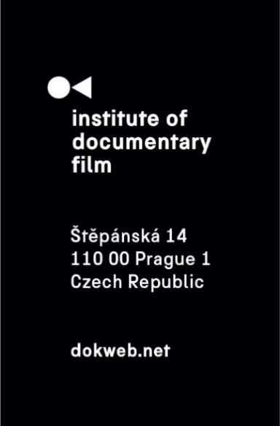
Jihlava, 30th October, 2019

Silver Eye Awards 2019 for Anna Eborn's Transnistra and Eliška Cílková’s Pripyat Piano

For the 11the time, Silver Eye Awards were given by the IDF to the best CEE films in East Silver Market. The international jury awarded Transnistra by Anna Eborn in the feature length category. Pripyat Piano by Eliška Cílková was awarded in the short category.
During the Closign Ceremony of Ji.hlava IDFF on October 28th, the Silver Eye Award in the feature length category was announced. Anna Eborn’s Transnistra was given the Silver Eye Award. The jury, comprised of Heleen Gerritsen (goEast, Germany), Karin Rywkind Segal (Docaviv, Israel) and Luisa Schwamborn (New Docs, Germany), stated: „Beautifully shot on 16mm, this is a powerful film that captures an in-between moment, at the end of adolescence, a play of youth and light located in a rural place, in an unrecognized country. A very loving view on a dynamic group focused around an unusual and unforgettable female character.“
The Special Mention was given to The Wind. A Documentary Thriller by Michał Bielawski. „Through mystical images and enigmatic protagonists, the filmmaker suggests an extreme connection between human faith and fortune, nature and the weather. Often Lynchian, the director's filmmaking achieves a true thriller as the title suggests."
In short films category, the international jury awarded Pripyat Piano by Eliška Cílková, „a poetic film that is a compelling combination of sound, image and tone“. The Special Mention was given to Waiting for a Miracle by Aljona Surzhikova. Read about the awards ceremony, which took place during the Festival Hub on the 27th October, and see the photos here.
11 films were nominated in the Short category, and 10 films were nominated in the Feature length category. The winner in each category received not only a unique award trophy, but also a prize money of 2 500 € and a year-long festival service of the East Silver Caravan worth of additional 2 500 €.

Silver Eye Award 2019 nominees – feature length documentaries:
When the Persimmons Grew (dir. Hilal Baydarov, Azerbaijan, Austria, 2019)
Movements of a Nearby Mountain (dir. Sebastian Brameshuber, Austria, France, 2019)
Spoon (dir. Laila Pakalnina, Latvia, Lithuania, Norway, 2019)
Hungary 2018 (dir. Eszter Hajdú, Hungary, Portugal, 2018)
The Wind. A Documentary Thriller (dir. Michał Bielawski, Poland, Slovakia, 2019)
Transnistra (dir. Anna Eborn, Sweden, 2019)
Come with Us (dir. Mihai Dragolea, Romania, 2019)
Over the Hills (dir. Martin Mareček, Czech Republic, 2019)
A Year Full of Drama (dir. Marta Pulk, Estonia, 2019)
Telenovela: Grey-Scale in Color (dir. Filip Martinović, Serbia, Spain, 2019)
Feature length documentaries jury:
Heleen Gerritsen (goEast, Germany)
Karin Rywkind Segal (Docaviv, Israel)
Luisa Schwamborn (New Docs, Germany)
Silver Eye Award 2019 nominees – short documentaries:
Infinity is 50 Meters Away (dir. Daniel Światły, Poland, 2018)
Terraria (dir. Hanna Hovitie, Hungary, 2019)
The Day After the Afternoon (dir. Khosro Khosravi, Hungary, 2018)
Currents (dir. Katerina Duda, Croatia, 2019)
Wild Berries (dir. Marianna Vas, Hedda Bednarszky, Romania, Portugal, Hungary, 2018)
Blue Frontier (dir. Ivan Milosavljević, Serbia, Slovenia, 2019)
The Tough (dir. Marcin Polar, Poland, 2019)
Pripyat Piano (dir. Eliška Cílková, Czech Republic, 2019)
Waiting for a Miracle (dir. Aljona Surzhikova, Estonia, 2019)
Boundaries (dir. Yuliya Shatun, Belarus, 2019)
Then Comes the Evening (dir. Maja Novaković, Serbia, 2019)
Short documentaries jury:
Ingrid Beerbaum (International Short Film Festival interfilm, Germany)
Laurence Boyce (PÖFF, Estonia)
Matt Lloyd (Glasgow Short Film Festival, United Kingdom)

